**Project:**

**HR Data Analysis Report**

Content

* Problem Statement
* Business Problems / Analytical Goals
* Tools
* Solution Approach
  + Step 1: Understanding Source data and analytical goals
  + Step 2: Transforming and Shaping source data (Data Cleaning)
  + Step 3: Data Modelling
  + Step 4: Creating DAX measures
  + Step 5: Data Visualization OR Dashboarding
  + Step 6: Analysis Validation
* Final Dashboard Report (Screenshots)
* Derived Insights
* Problem Statement

A Business organization performs well as it generates good profit and has an increasing market share currently in the market. Also, they build and maintain an excellent workforce through effective and strategic hiring and also by providing a variety of training in various fields, according to market trends.

However, they observed there is comparatively higher attrition in the last couple of quarters in the company. Hence, the HR team is trying to understand where the problem lies for the employee force. The HR department is responsible for monitoring and managing various aspects of employees of the company.

HR team hired a consulting firm for their services, where you work as a Business Analyst, and this case is allocated to you by the firm.

You had a couple of business discussions with the HR team where you understood their business scenario. Now it's your responsibility to make a detailed analysis of the case and create a data analysis report, they have provided you with their recent employees’ data.

Your data analysis report should meet the analytical targets/queries of the HR team presented to you in the business discussions. Along with the analysis report, they expect you to present the key insights from your side using your created analysis report.

Business Problems / Analytical Goals

* KPIs to evaluate the business performance at a higher level.

1. Attrition % rate.
2. Attrition count
3. Currently working employees’ strength
4. Ex-Employees count
5. Total salary budget paid to employees
6. Employees’ key rating feedback

* Analysis report should be able to track and capture different aspects of employees like,

salary and payouts breakdown,

employee’s experience in the organization, etc

* Segregation of Employees by
  1. education degree
  2. current job roles
  3. Gender and age groups
  4. Marital status
  5. Performance status
* Paid salary budget by different departments.
* Segregation of various payouts/incentives/bonus/allowances amounts given to employees, by different categories like departments, job roles, job levels, etc.
* Segregation of employees by their different performance parameters like work experience, salary hike, years since last promotion, salary, total years being in the company, overtime shits involvement, etc.

This segregation should be filterable by different categorical values like age groups, job roles, etc.

* Feedback rating breakdown analysis as, the number of employees by their submitted ratings for different feedback parameters like work life balance, job satisfaction, environmental satisfaction, etc.
* Average rating analysis breakdown by different categorical values like average rating by departments/age group/ gender/job roles, etc.

The analysis report should be able to meet the above analytical goals for currently working employees as well as Ex-employees separately.

**Employee’s Policies for payouts**

* The company provides an extra 5% of the monthly base salary as a Marital allowance to their employees who are married.
* Based on the business travel preference of employees, the company provides business travel allowance to their employees, on the range-

Business Travel allowance=

* 1. 0% of monthly base salary

for the “No Travel” preference category.

* 1. 2 % of monthly base salary

for the “Rarely” preference category.

* 1. 5 % of monthly base salary

for the “Frequently” preference category.

* The company provided an extra amount as a performance bonus to their employees according to their performance tag/rating.

The performance bonus payout range is as below-

1. 15 % of annual base salary

For Performance = “Excellent”.

1. 5 % of annual base salary

For Performance = “Good”.

1. 0 % of annual base salary

For Performance = “Average”.

* The company provided an extra amount as an Overtime incentive to their employees according to their Overtime.

Over time incentive payout range is as below-

1. 10% of monthly base salary

For Overtime = “Yes”.

1. 0 % of monthly base salary

For Overtime = “No”.

* The company provided an extra amount as a daily Office Travel allowance to their employees according to their performance feedback tag.

Daily Office Travel allowance condition is-

Employees who achieve a performance tag/feedback as ‘Excellent’ will get paid Rs. 20 per Kilometre per day for 260 working days for in a year.

* Tools

1. Microsoft Power BI
2. PostgreSQL Database & pgAdmin 4

* Solution Approach

**Step 1: Understanding Source data and analytical goals**

The first and most important thing is to understand the given raw data based on the business problems we going to solve. The company’s business problems should be considered as analytical goals that will be implemented while creating the dashboard report & and visualization.

**Step 2: Transforming and Shaping source data**

After concluding our project’s analytical goals, we are heading to the tool Microsoft Power BI where our first step is to perform ETL operation on the source data.

Specifically, we will import raw data files (excel files) in Power BI, then the data will be transformed and shaped using the power query editor of Power BI.

The raw data is possibly not in the appropriate shape hence it’s important to clean it in the first place. As it may contain null values, empty values, or inconsistent values.

example-

the Quantity column contains values: 1, 2, 3, 4, … and “one”, “two” etc.

The source data may be provided in a single large table/excel file. Which may consist sort of redundancy and hence, the bulky size of the table. This kind of data can be more concisely viewed and more efficiently analysed if we split it into multiple tables (called Normalization).

While Splitting large tables into multiple smaller ones, we preferred to group up columns into a table form that consisting correlated data.

Like,

Salary columns and all types of payouts, allowances, bonuses, incentives, etc are grouped into a separate table.

Different rating and feedback parameters data are grouped into a separate table.

In this step, we will also create some new data columns from the existing columns data. HR team provided us with their Employee’s Payout policies, and using these policies and conditions we added up new columns.

After transforming the source data, the data is loaded to the front-end of Power BI.

**Step 3: Data Modelling**

In recent steps, we’ve toned get shaped our data. However, the tables are still separate objects which have no connection or relationship between them.

Here Data modelling comes into the picture, where we create relationships between the tables. Due to establishing relationships among data in the tabular form, it can be viewed as a single model.

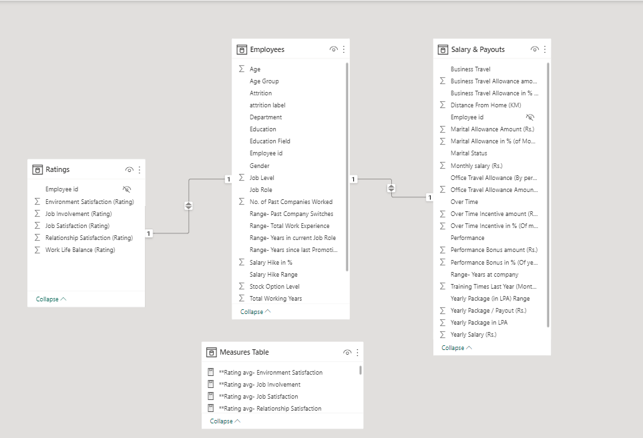

**Step 4: Creating DAX measures**

Dax measures are essential to perform analytical aggregation on the different segments of data. We have created a list of DAX measures below



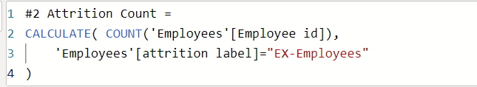

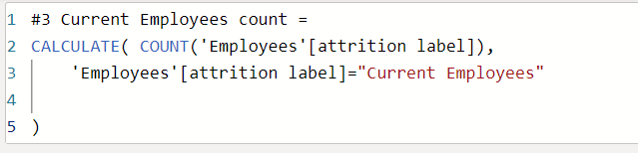

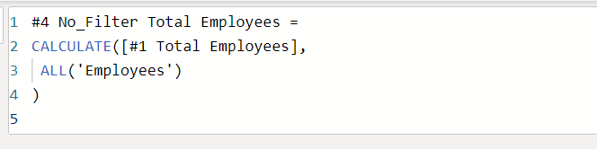

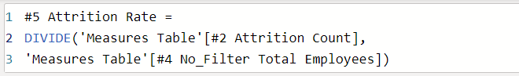

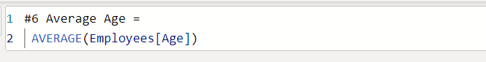

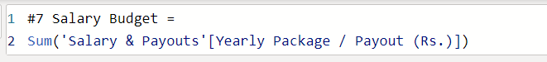

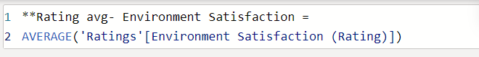

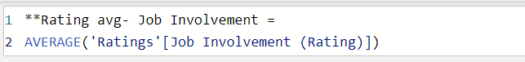

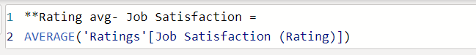

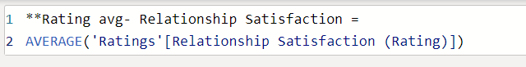

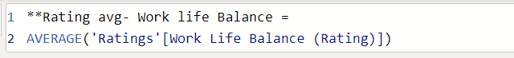

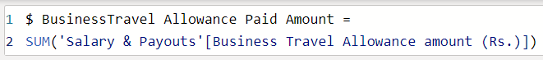

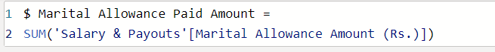

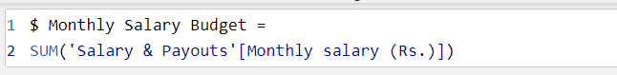



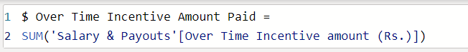

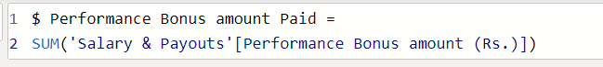

**Step 5: Data Visualizations / Dashboarding**

This is the most significant step where we bring our data live by creating a dynamic and interactive dashboard. For data visualization, we used the MS Power BI tool.

As we had provided a mock-up dashboard, we have considered it for reference, specifically to choose visual needs to be included.

The dashboard is built with the assumption that the intended end consumers of the dashboard are managerial-level people and stakeholders. Therefore, it contains less low-level details and more conclusion-based data representation.

**Step 6: Analysis Validation**

In this step, we going to validate the out numerical values of our final dashboard. To cross check whether the derived values on visualization charts are accurate and error free, we implementing SQL queries for every respective visualization, and matches output values of our SQL queries with the dashboard values.

For the Analysis/Data validation, we have used PostgreSQL database and pgAdmin 4 tool. Firstly we import data (in the form of CSV files) from our data model we created in the power BI. After creating a database and relational tables within the database, we imported data into the relational tables. With this our data validation preparation steps are done.

In the data validation of the ‘HR data analysis’ dashboard which consist four pages, we have executed **140+ advance SQL queries** to validate every significate visualization chart and their different view.

In these 140+ SQL queries we implemented advance SQL concepts like Aggregation and Group by, Comment Table Expression (CTE), Joins, Order by, etc, in order to match the queries output with the respective visualization chart’s output values.

We have created a separate ‘**Data Validation Report’** for the project, where we list our all the **140+ Advance SQL queries** with their respective outputs, and respective visualization chart.

Kindly refer it.

* Final Dashboard (Screenshots)

Page 1: Employees/Home

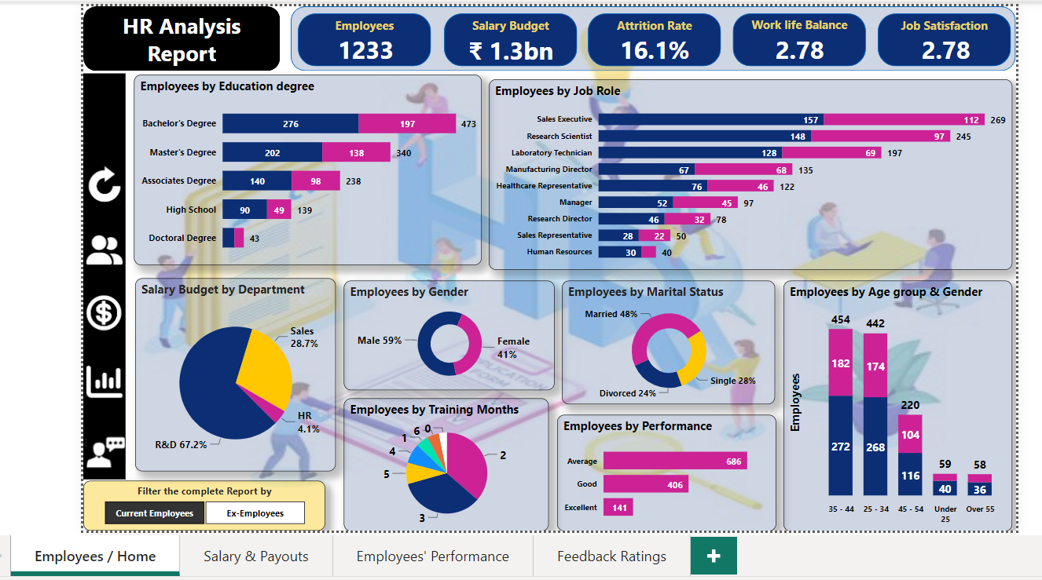

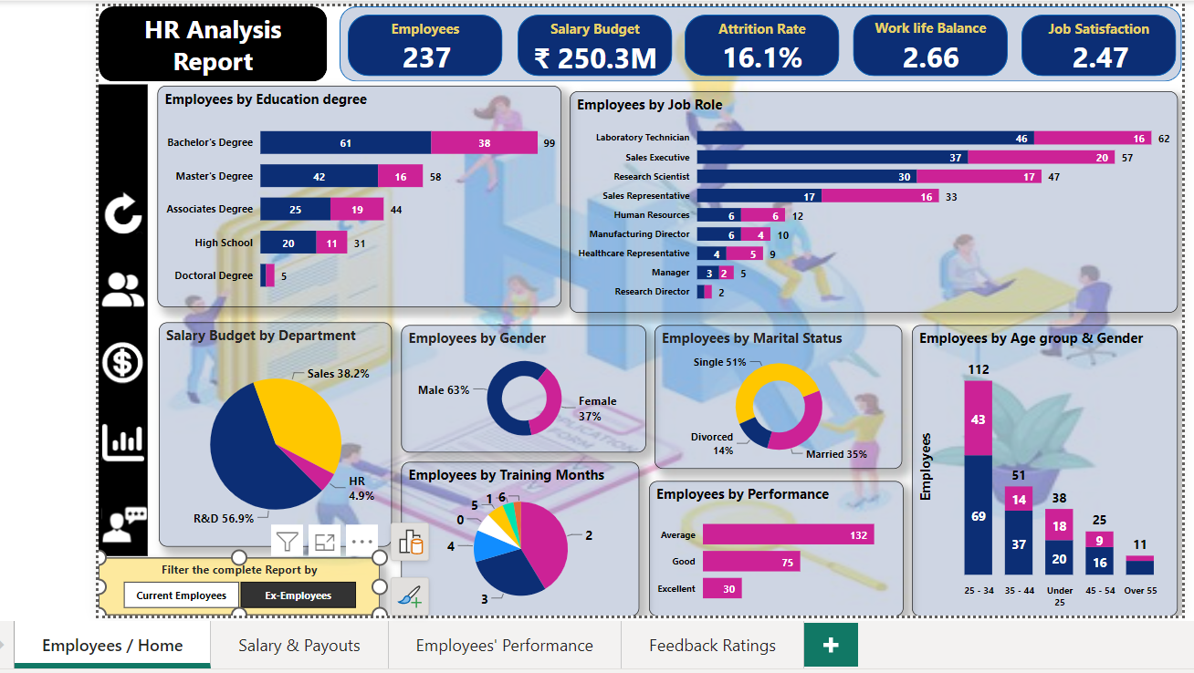

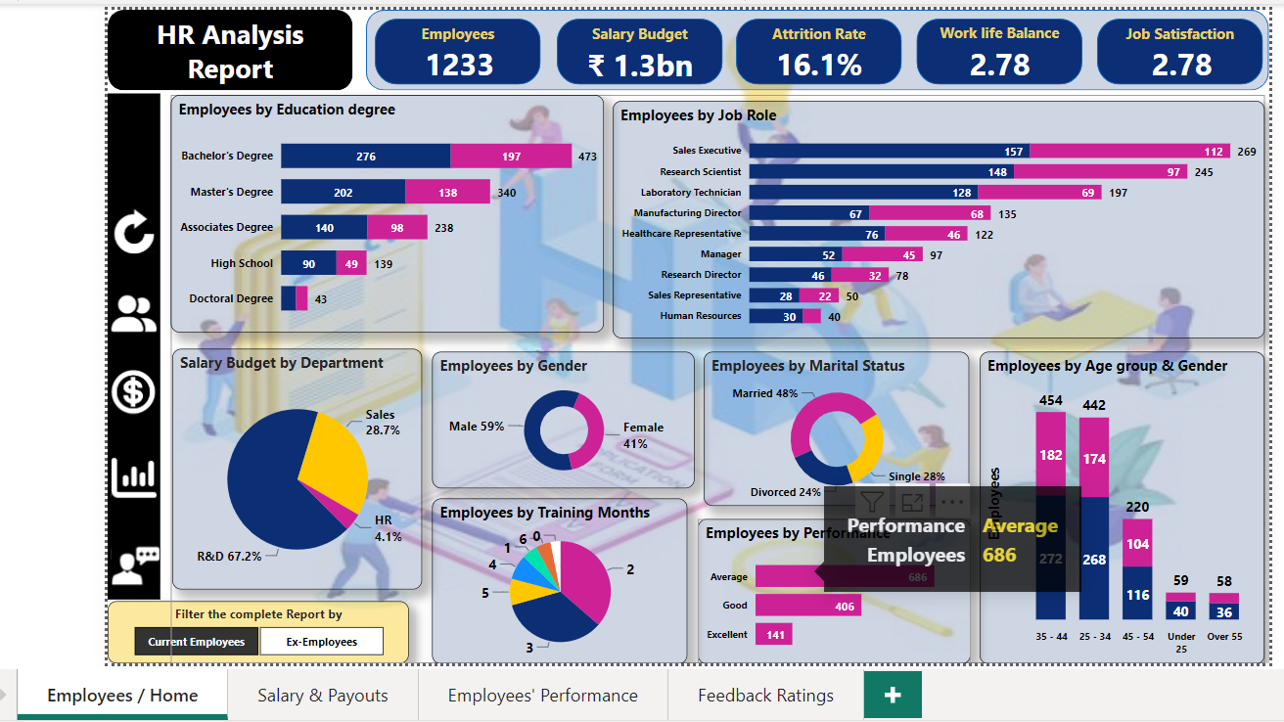

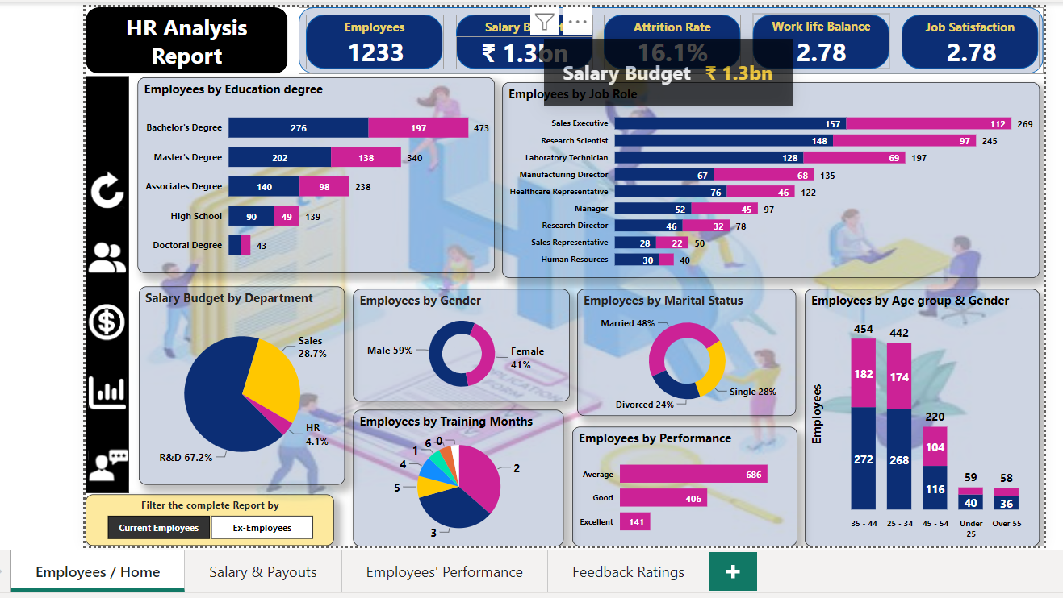

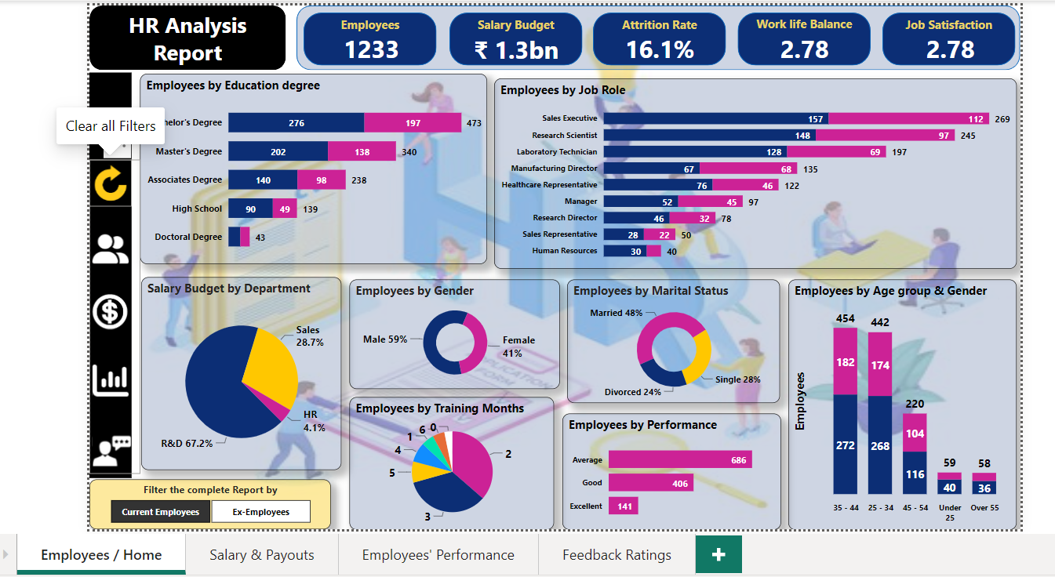

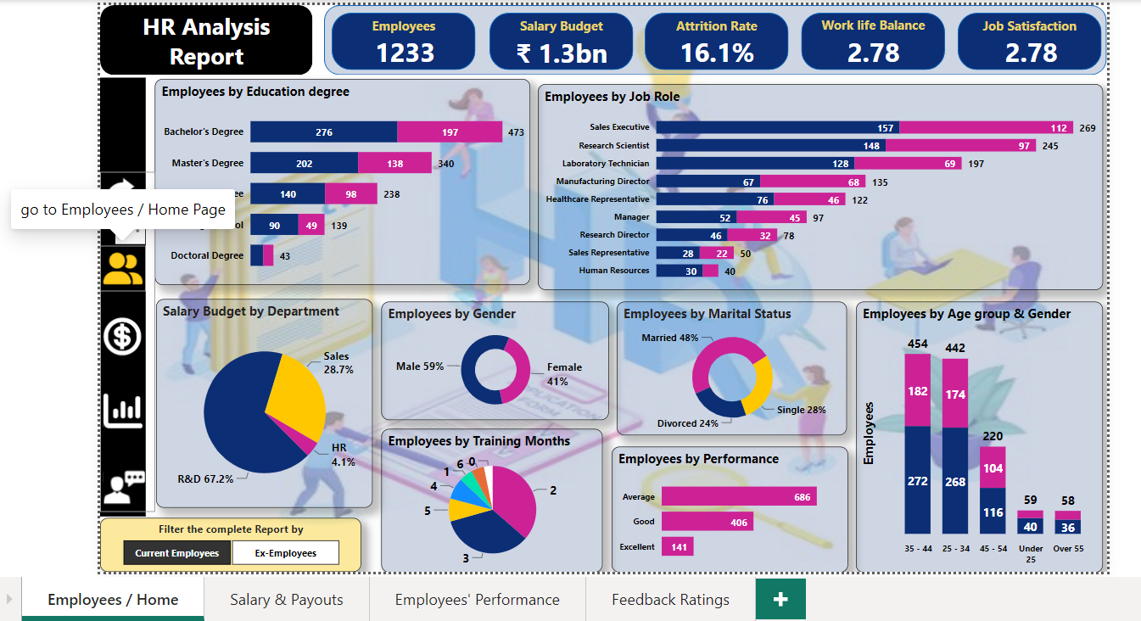

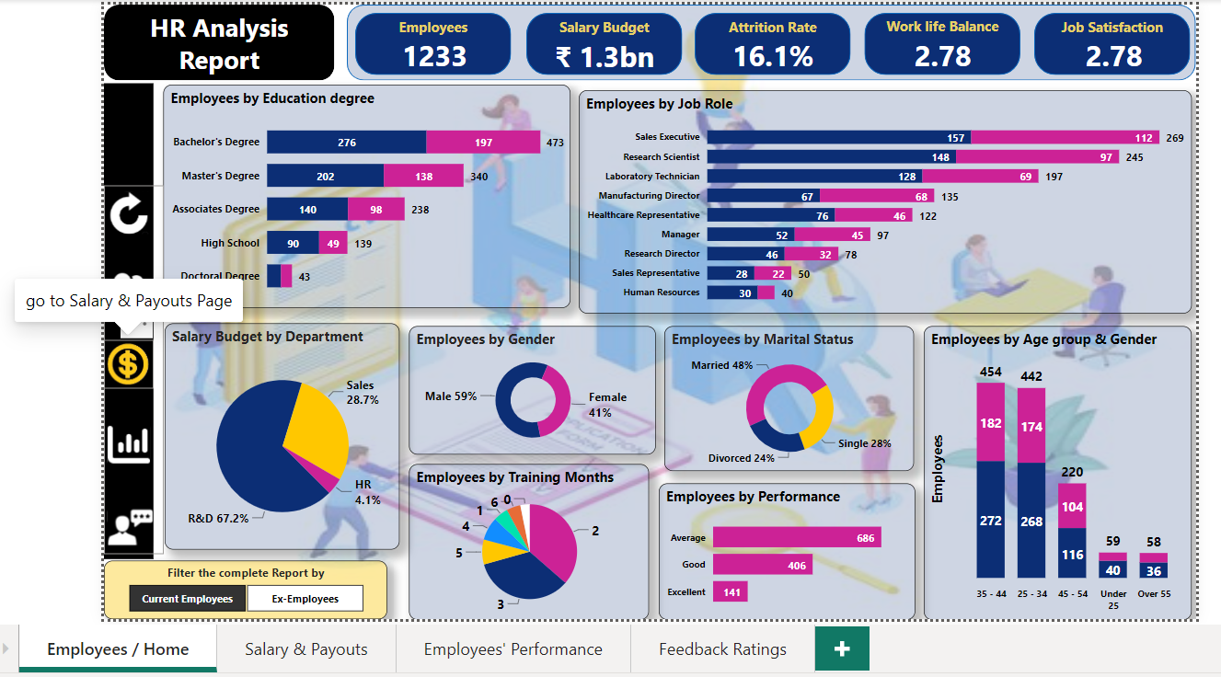

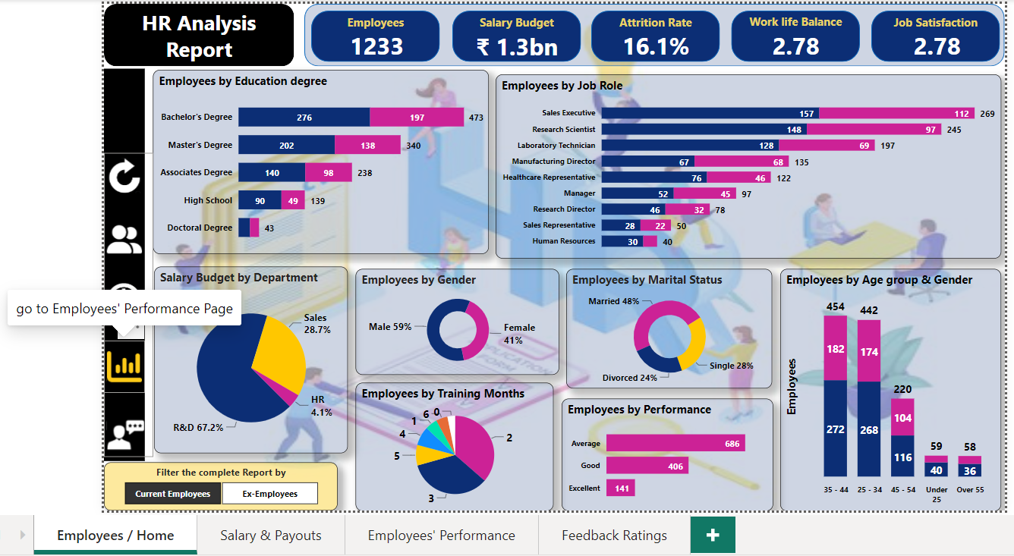

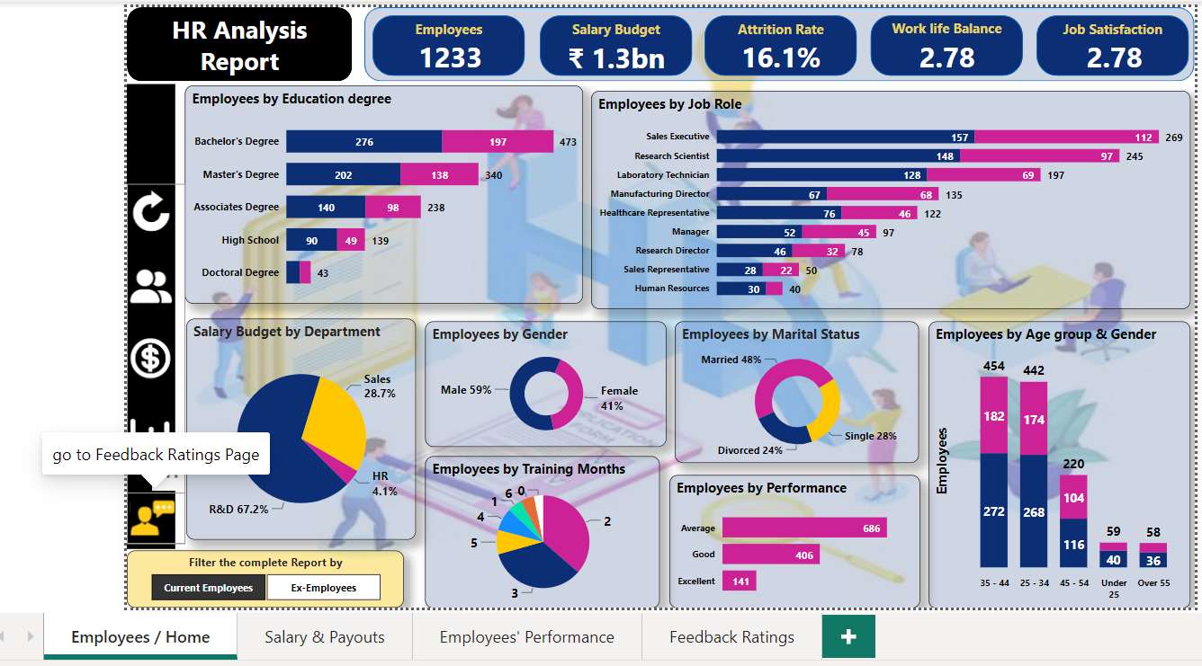

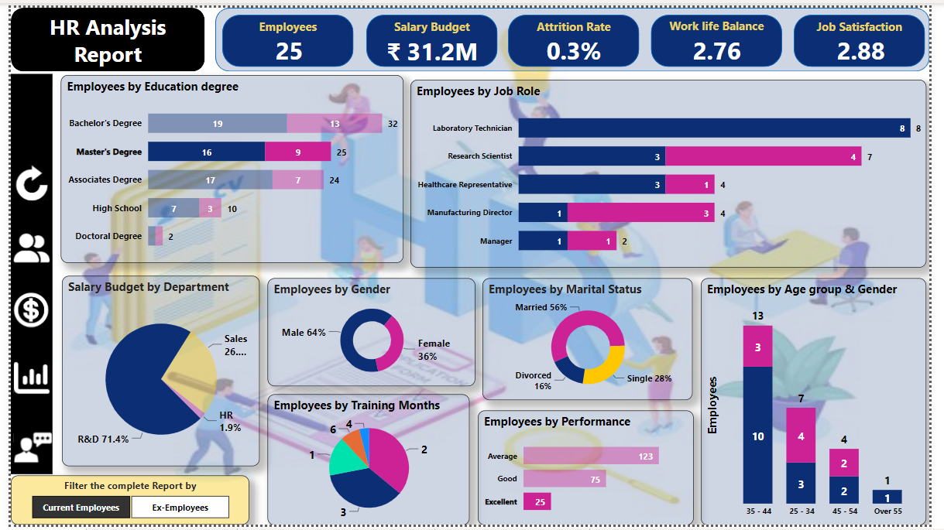

Page 2: Salary & payouts

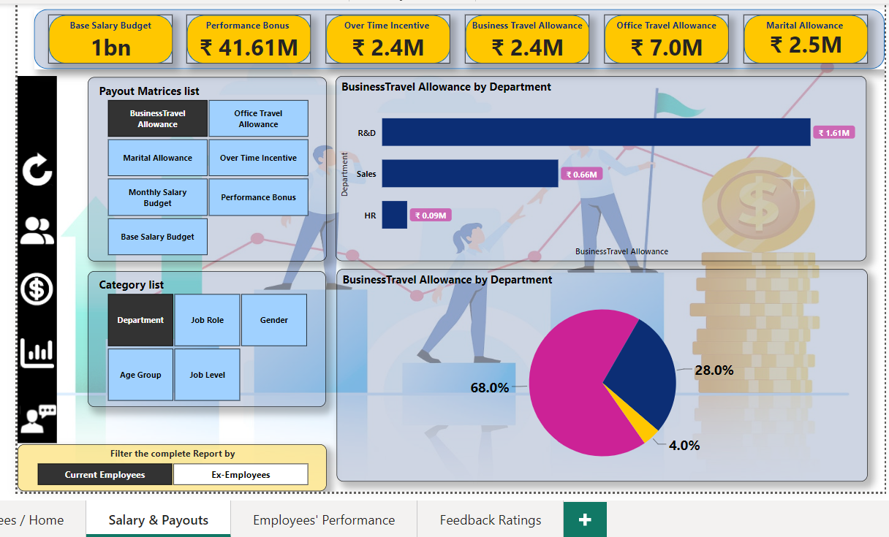

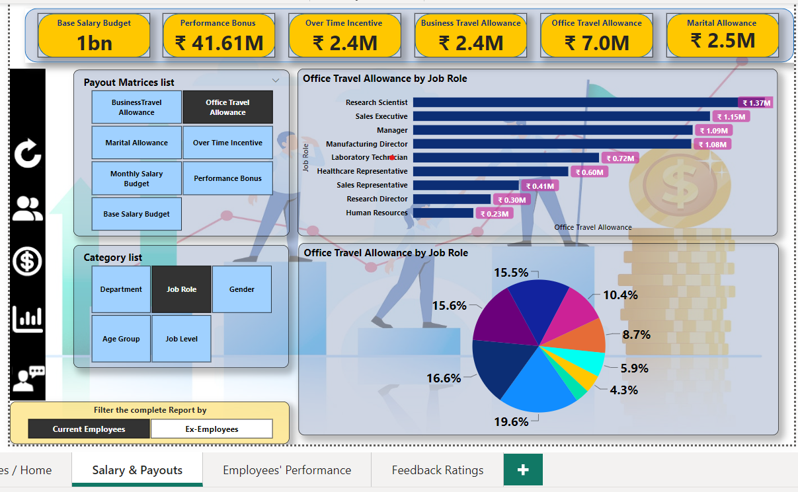

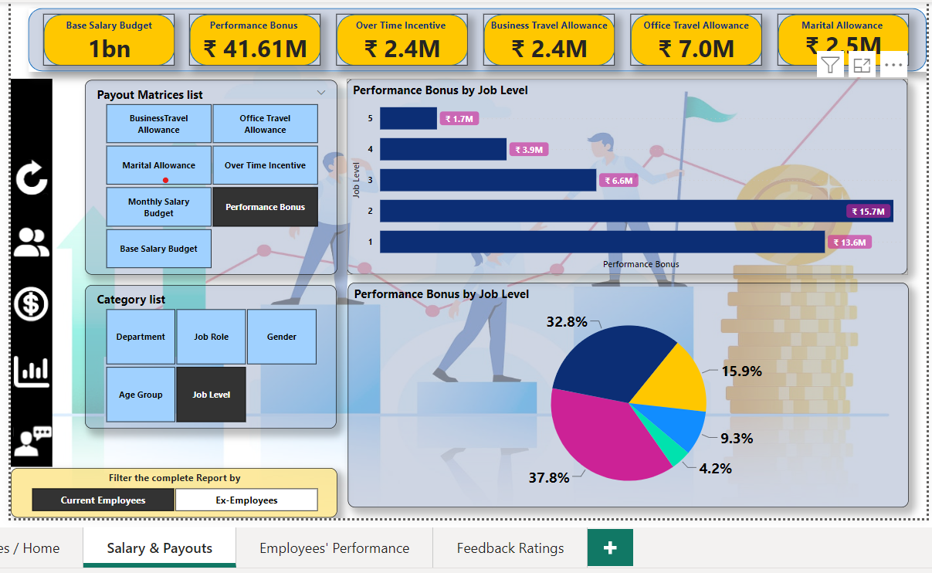

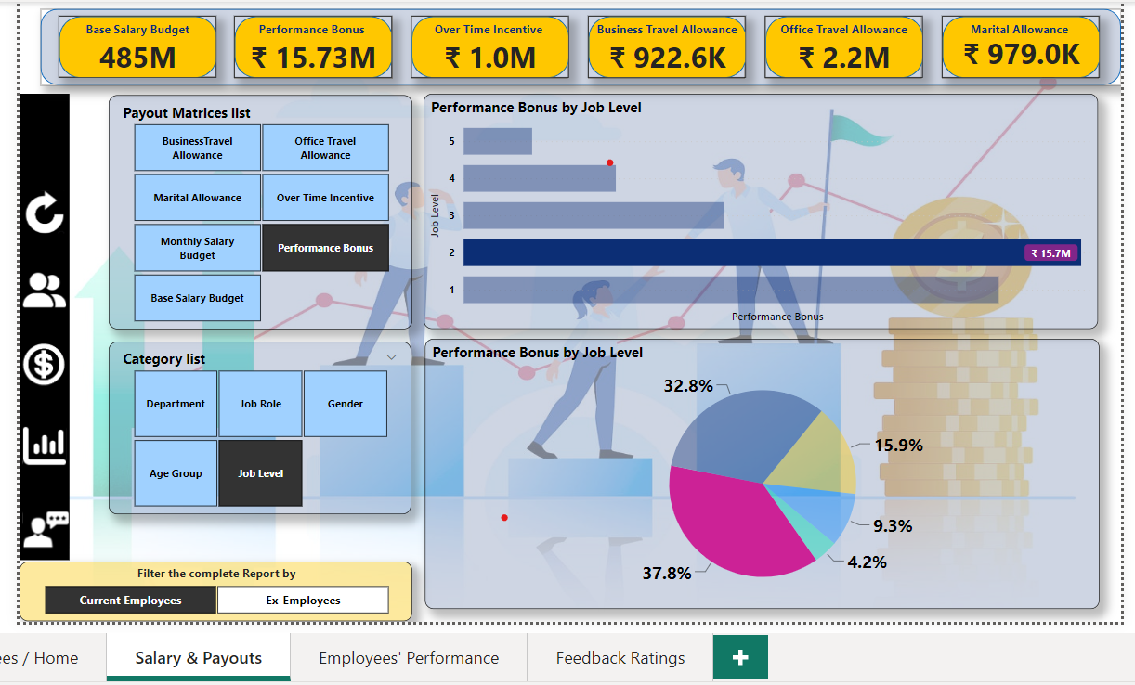

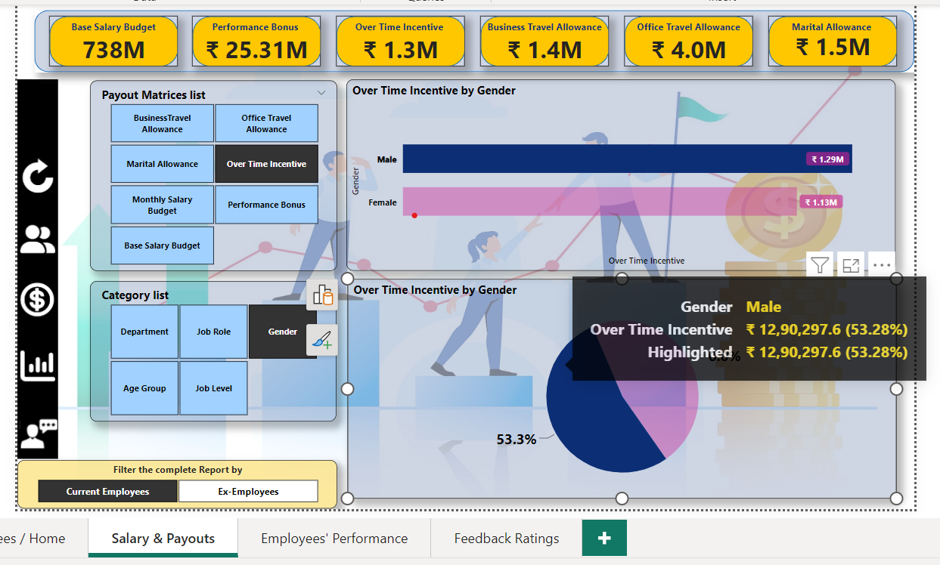

Page 3: Employees’ Performance

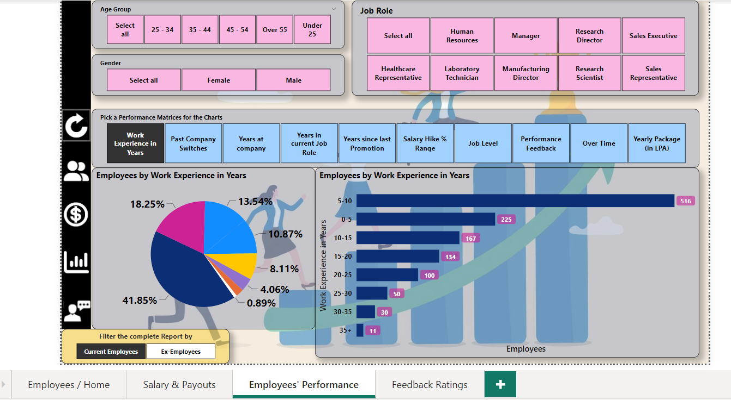

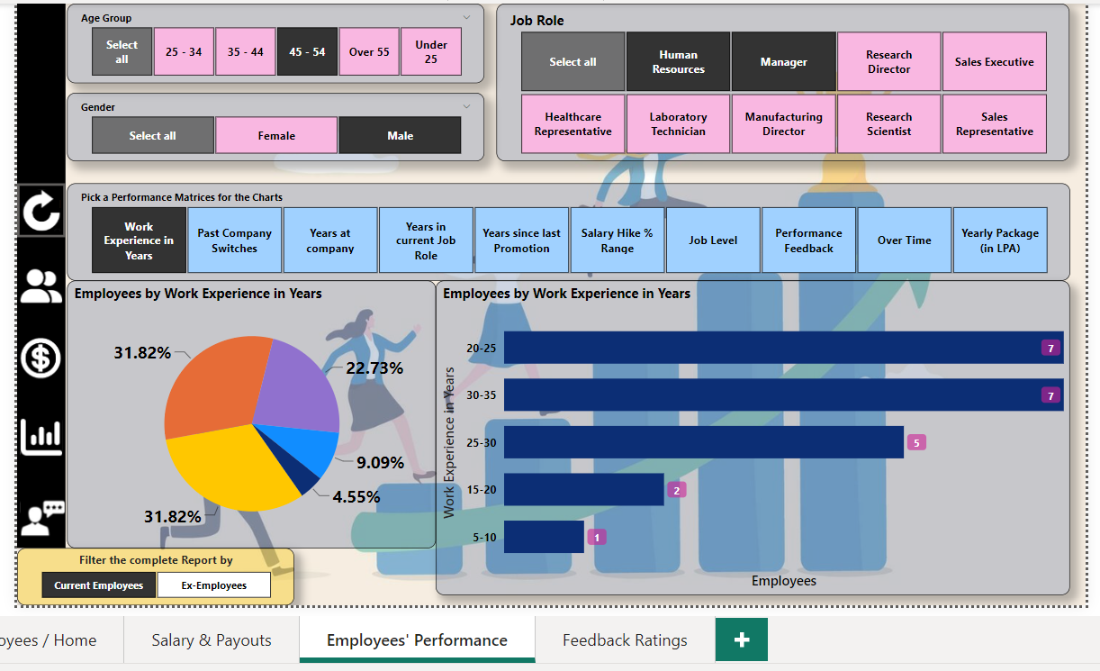

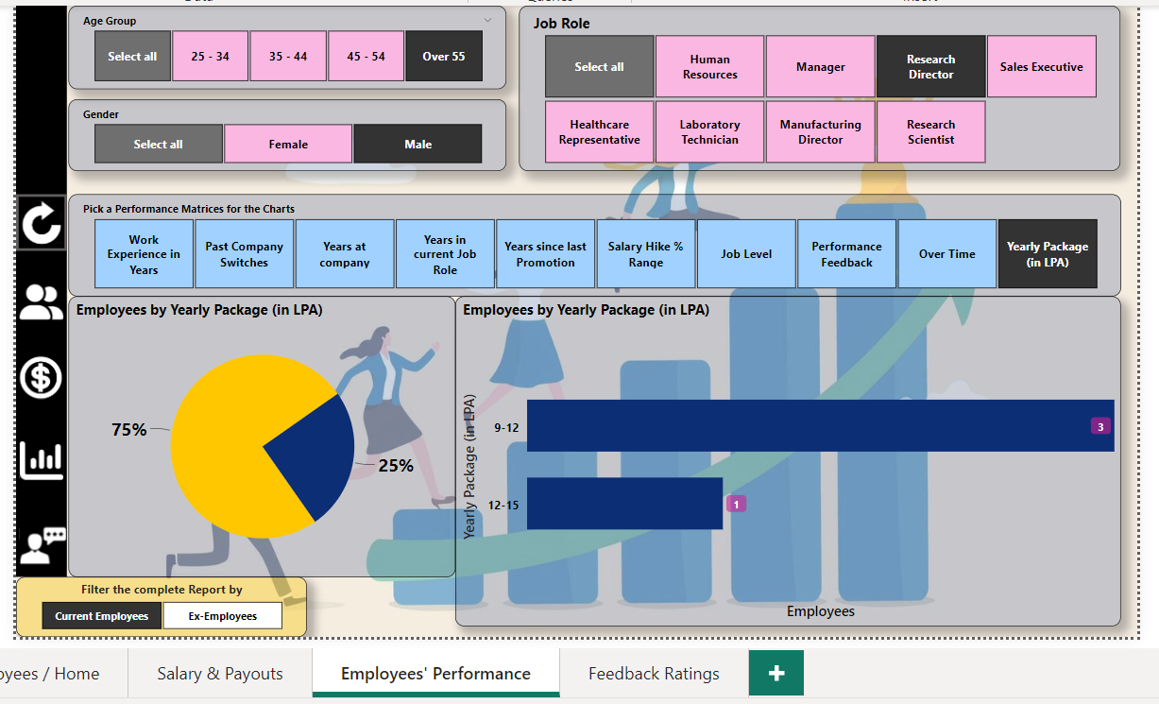

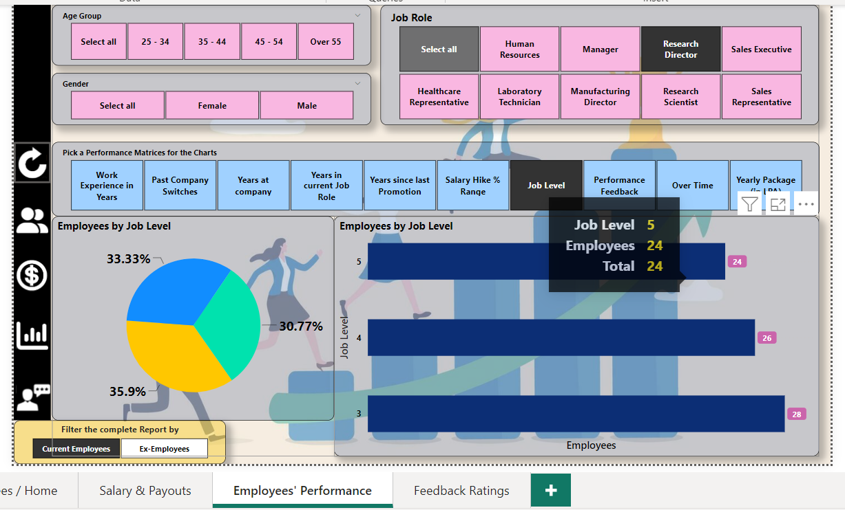

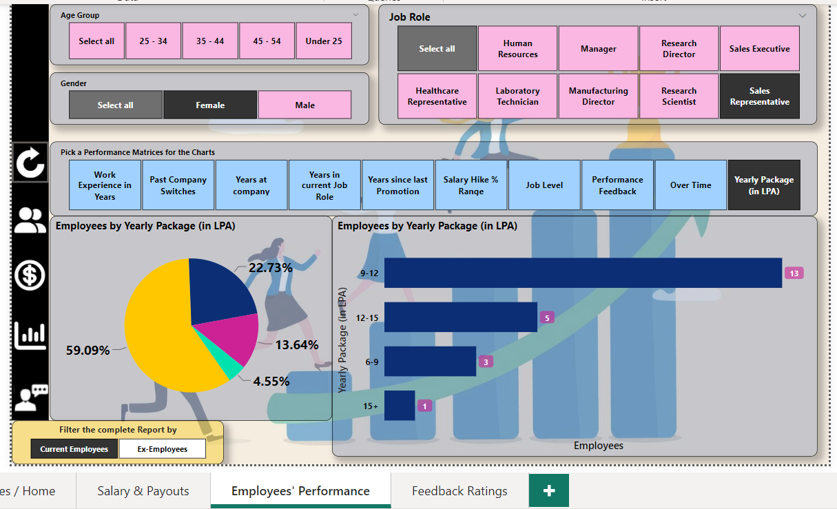

Page 4: Feedback Ratings

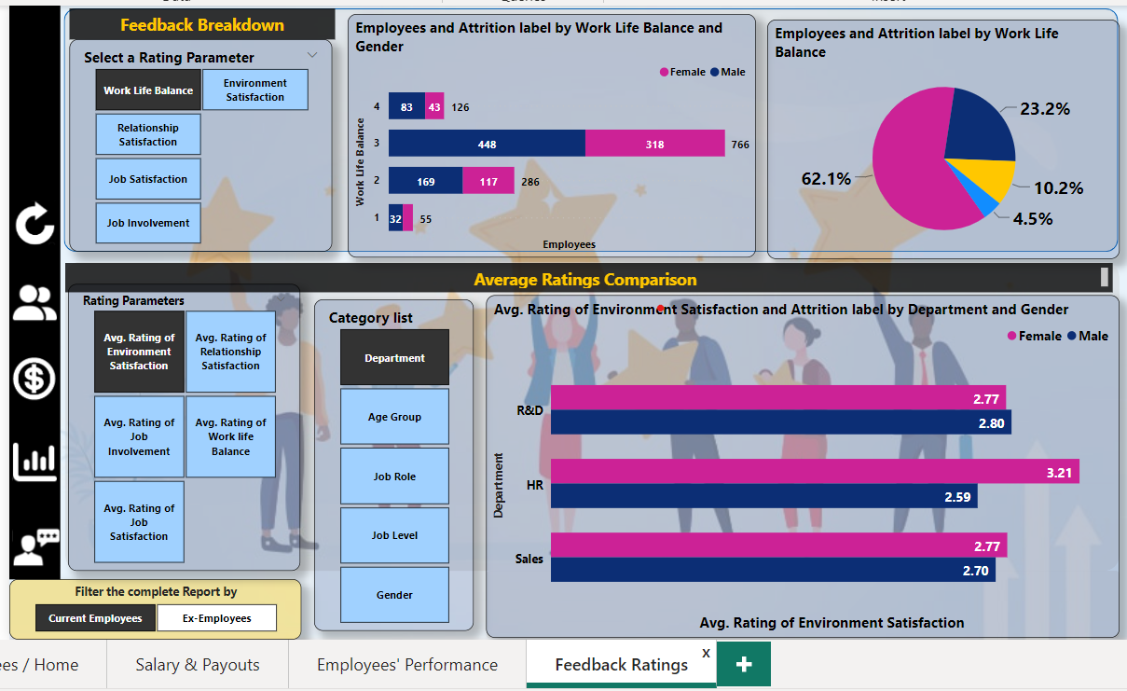

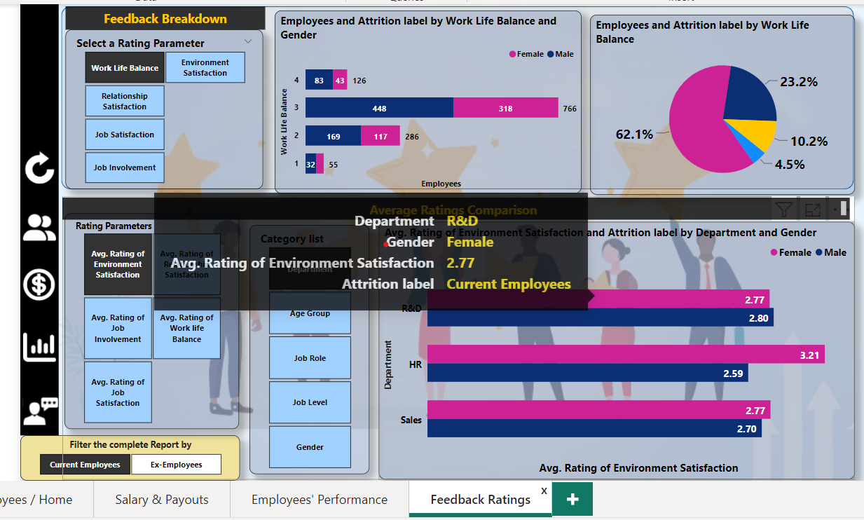

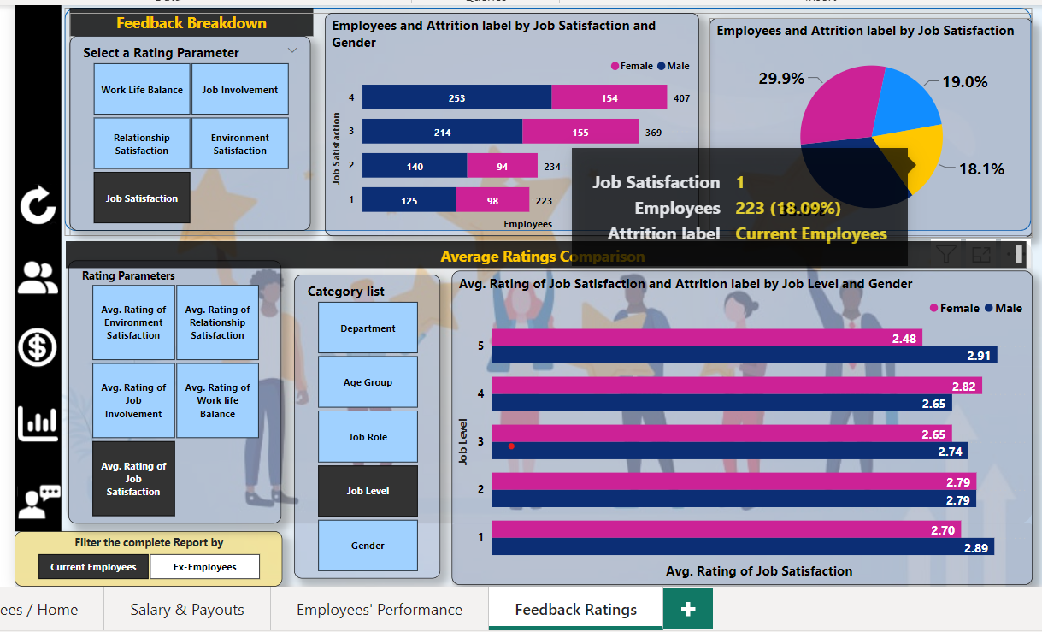

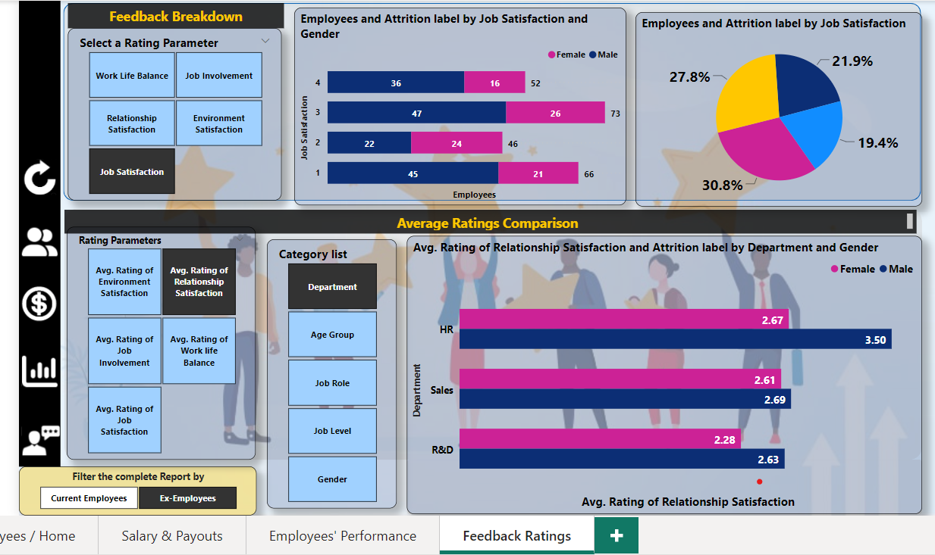

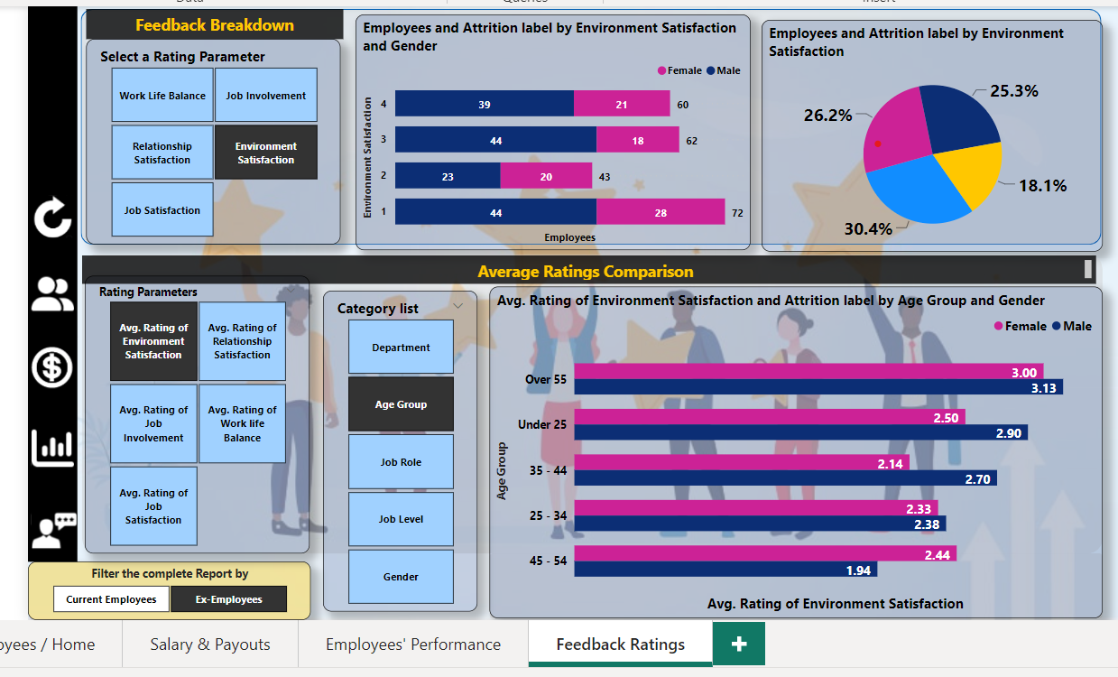

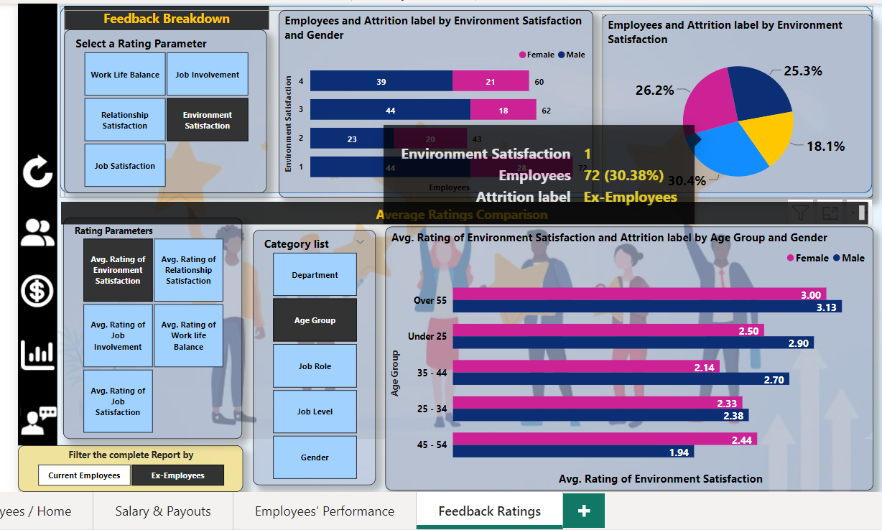

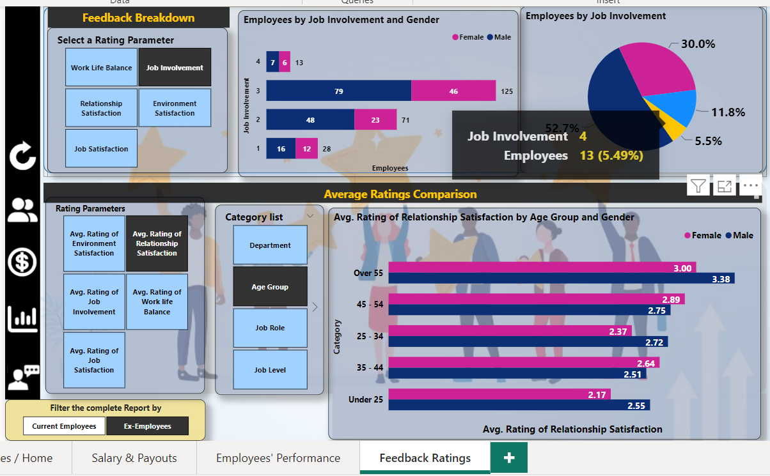

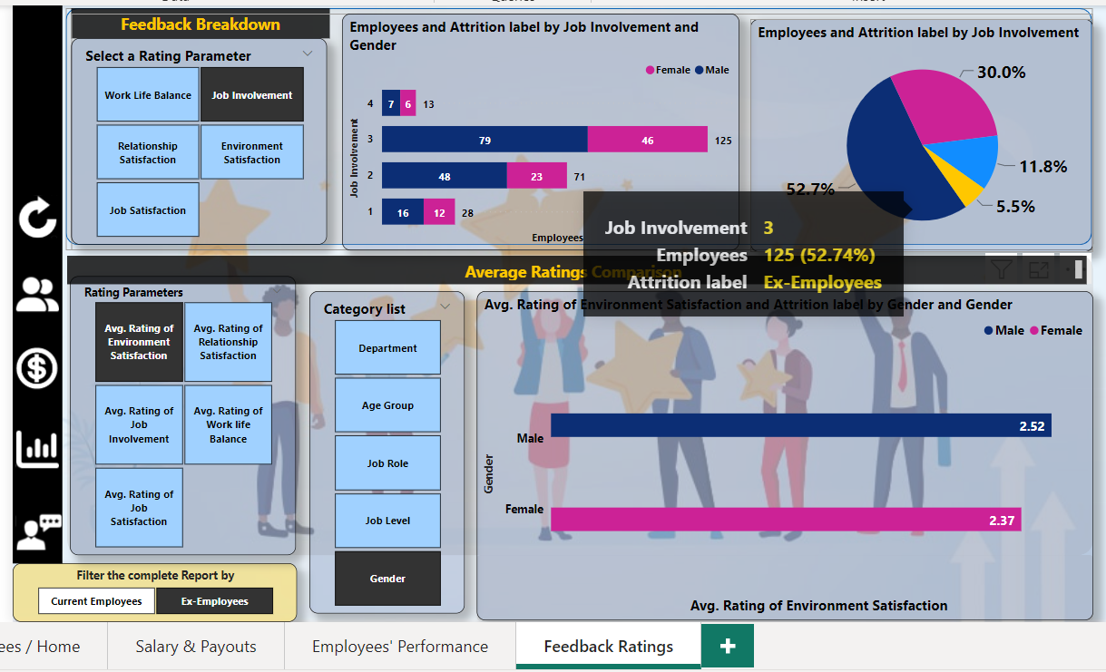

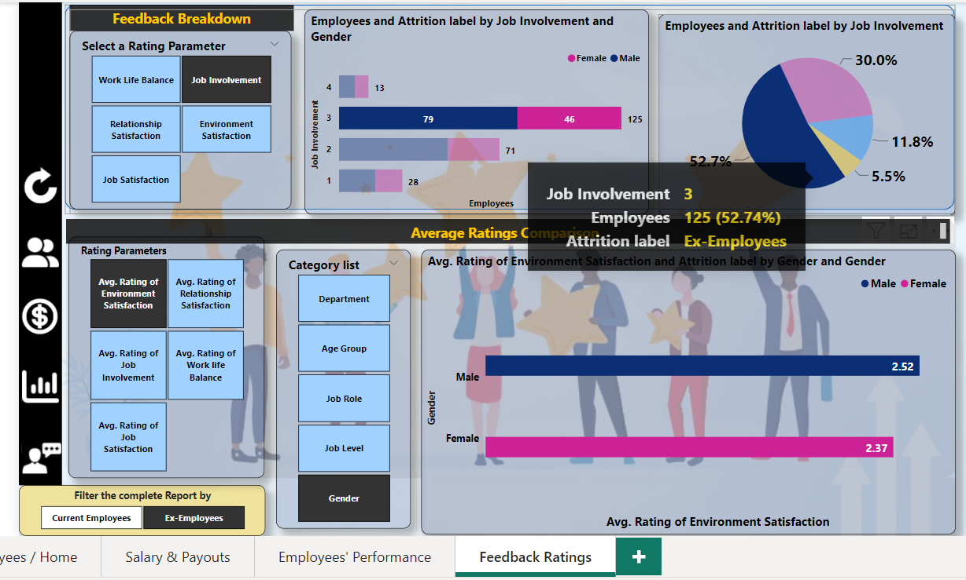

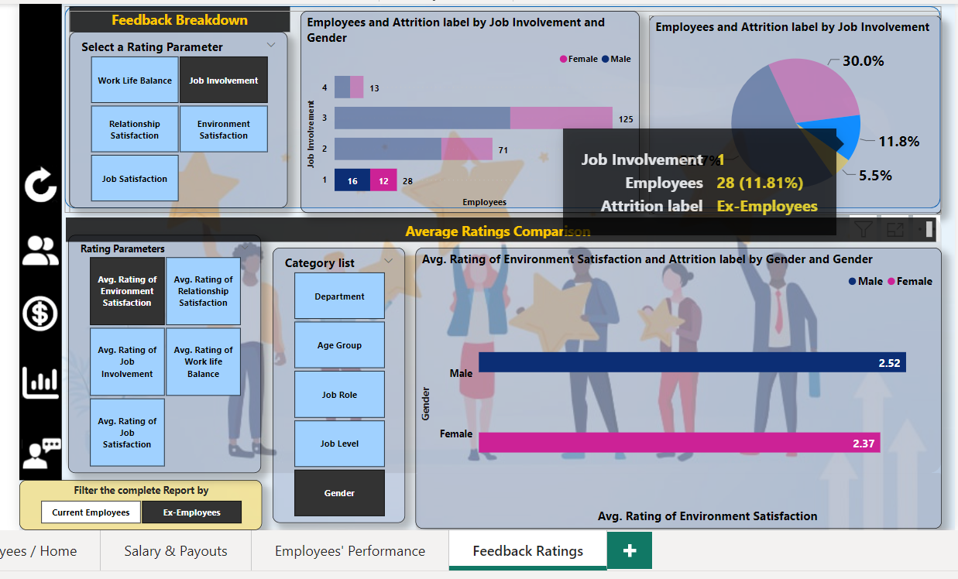

* Key Insights

1. Primary KPIs-

Current Employees-

1. Employees count= 1,233
2. Salary Budget = Rs. 1.3 Bn
3. Average rating of ‘Work life balance’= 2.78
4. Average rating of ‘Job Satisfaction’= 2.78

Ex-Employees-

1. Employees count= 237
2. Salary Budget = Rs. 250.3 Mn
3. Average rating of ‘Work life balance’= 2.66
4. Average rating of ‘Job Satisfaction’= 2.47
5. The Business Attrition rate is 16.1 %, which means almost 16% of employees leave the company.
6. 63% of employees are male and 37% are female. Of the 16% of employees who leave the company, almost half of the employees belong to the job role-
7. Laboratory Technician
8. Sales Executive
9. Research Scientist
10. 50 % of employees who leave the company are of the age group ’25 to 34’, which is the most capable segment of the workforce.
11. Your 50 % workforce (either current or Ex) is on the average level in terms of performance, which means 50% workforce is underperforming.
12. The R&D department’s budget is highest either as base salary or any extra payouts, after R&D, there is the Sales department, and finally HR.

However, almost 98% of employees in the Research Scientist job role belong to job level 1 or 2.

1. Your total Salary budget is Rs. 1.3 billion and the total base salary is Rs. 1 billion.

That means your company spends almost Rs. 0.3 billion on-

* Business Travel Allowance = Rs.2.4 million
* Office Travel Allowance = Rs. 7 million
* Performance Bonus = Rs. 41.61 million
* Marital allowance = Rs. 2.5 million
* Over Time incentive = Rs.2.4 million

1. 10% of your current employee base has a background of more than 6 company switches. Therefore, there is a chance that this group of people would be in your upcoming Ex-employees list.
2. In a general scenario, 80% of your employee base gets promoted to the next position.
3. On average, an employee works with your company approximately for the period of 5 to 10 years. That means in every 10 years your 70% to 80% workforce gets renewed.
4. 80% of Ex-employees have job level 1 or 2.

--------------------------------------------------------------------